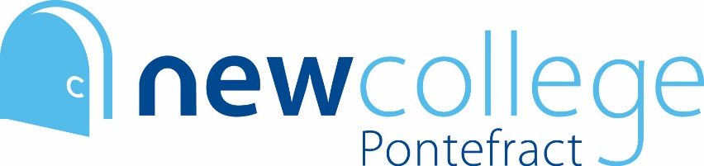

SUMMER INDEPENDENT LEARNING: “All about me” Task

We at New College feel it is very important we get to know you as individuals so that we can best support you throughout your time here. For this reason, we’d like you to complete the quick task below in addition to the study skills and subject work.

Task Instructions

- Tell us about you! Write some bullet points (using the prompts below) to let your teachers know who you are.
- Save this information in a document that can be shared electronically with your teachers in September – they will tell you how they’d like you to do this in your first few lessons.

Things we’d like to know
- Do you have any hobbies? How do you spend your free time?
- Why have you chosen the subjects you are about to study?
- What are you thinking you’d like to do when you finish your studies with us – university? Apprenticeship? Employment? Gap year?
- What are your career aspirations?
- Anything else you think it would be valuable for your teachers/tutors to know?

